

##### Question/Answer Booklet

Name:

Yr 11 ATAR PHYSICAL EDUCATION STUDIES

Sport Psychology Class Test 2021

**Time allowed for this paper**

Working time for paper: 45 minutes

**Material required/recommended for this paper**

*To be provided by the supervisor*

This Question/Answer Booklet

|  |  |  |  |
| --- | --- | --- | --- |
| **Contents:**  Sport Psychology | Multiple choice  Short answers  Extended questions | 10 marks  22 marks  18 marks  **Total marks** | **/50** |

**Multiple Choice (10 marks)**

1. In tennis, prior to each service point, most players will use a performance routine. How does this help the player focus their attention on the serve?

1. Limits player distractions, such as the crowd and importance of the upcoming point
2. Regulates arousal levels in high pressure points
3. Identifies the task orientated ques for correct service technique
4. All of the above
5. Rookie athletes in their first season of professional team sports often require positive reinforcement from their coaches and peer mentors to improve their performance and learn their playing role within the team. This will assist the player in developing which mental skill?

(a) Stress Management

(b) Motivation

(c) Self-Confidence

(d) Self-fulfilling prophecy.

1. The recent international summer Test Cricket Series between Australian and India was tarnished by on field sledging. Sledging is a term used in cricket to describe the practice whereby some players seek to gain an advantage by insulting or verbally intimidating the opposing player. Which mental skills strategy would best assist a player experiencing sledging whilst batting?

(a) Imagery

(b) Relaxation techniques

(c) Goal Setting

(d) Self-Talk

1. An NFL gridiron quarterback player deciding on tactics at the next line of scrimmage for the upcoming play would be an example of which area of attentional focus in Nideffer’s model ?
2. Broad-external.
3. Broad-internal.
4. Narrow-internal.
5. Narrow-external.
6. Cristiano Ronaldo, Le Bron James and Usain Bolt are amongst the biggest names in world sport over the past decade. When compared to highly skilled athletes such as these, less skilled athletes are generally more motivated by:
7. extrinsic rewards.
8. intrinsic rewards.
9. knowledge of results.
10. self-fulfilling prophecy.

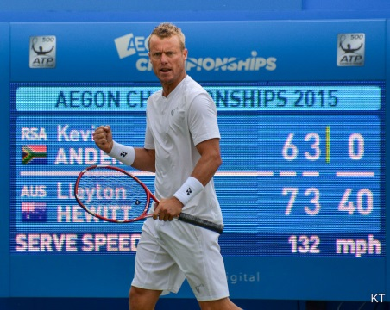6. Australian tennis legend Lleyton Hewitt (pictured right) was famous for yelling out ‘C’mon’ at important stages in his tennis matches. What mental skill strategy was he using and for what purpose?

(a) Self-talk for the purpose of motivation and building confidence

(b) Self-talk for the purpose of reinforcement of learning

(c) Performance routine for the purpose of motivation

(d) Performance routine for the purpose of building confidence

7. In a high pressure sporting situation, which of the following is not a physiological response to stress that an athlete would be likely to experience?

(a) increased adrenaline levels

(b) poor decision making

(c) muscular tension

(d) increased need to urinate

8. To give themselves the greatest chance of success, young athletes are advised to set goals that are;

(a) long-term and very challenging

(b) long-term and very achievable

(c) short-term and very challenging

(d) short-term and very achievable

9. Progressive Muscle Relaxation involves an athlete contracting a muscle for a short period of time, then releasing or relaxing. This type of relaxation would be best suited to:

(a) Decreasing anxiety before performing a soccer penalty kick.

(b) Increasing arousal before a soccer match.

(c) Increasing arousal before performing a soccer penalty kick.

(d) Decreasing anxiety before a soccer match.

10. The relationship between Ideal Performance State and athletic performance is best represented by:

(a) Bandura’s Model of Self Efficacy.

(b) Nideffer’s Model of Attention.

(c) Inverted-U hypothesis.

(d) Self-fulfilling prophecy.

**Short Answer (22 marks)**

**Question 11 (8 marks)**

1. There are 3 basic types of personal goals. Explain each using a sport example of your choice. (6 marks)

1. What does the acronym SMARTER stand for? (2 marks)

**Question 12 (2 marks)**

In terms of motivation, briefly describe **two (2)** differences you would expect to see between a young athlete and a mature/older athlete.

**Question 13 (6 marks)**

1. Nideffer’s Model of Attention identifies four possible types of attentional focus. Label the figure below. (2 marks)

**Width**

**Direction**

1. Provide a brief example for each of the four types of attentional control in relation to tennis. (4 marks)

**Question 14 (4 marks)**

Athletes at different stages of learning require different arousal levels for optimal performance.

In the space below, draw and label The Inverted-U Hypothesis demonstrating the differences in skill level between a beginner athlete, intermediate athlete and an advanced athlete.

**Question 15 (2 marks)**

During periods of stress an athlete may experience an increase in heart rate and respiratory rate. Identify **two (2)** additional physiological changes an athlete could experience that may affect their performance.

**Extended Answer (18 marks)**

**Question 16 (10 marks)**

1. With reference to the Inverted-U Hypothesis, explain the concept of arousal regulation and discuss the different levels of arousal required for the three sports identified in the pictures below.

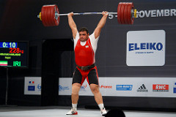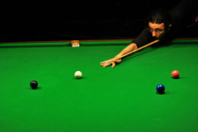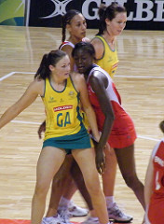 Snooker Weightlifting

Netball

**(8 marks)**

1. Australian cricket captain Steve Smith recently posted his highest test score of 239 runs against England at the WACA. In that particular innings he batted for over 9 hours before being dismissed.

Identify and define **two** mental skills that Smith would have developed throughout his career that would have allowed him to bat so well over such a long period of time and identify and explain **two** mental skill strategies he could have utilised whilst batting and how he would have implemented them throughout his innings to improve his performance.

**End of Topic**